Sennheiser TeamConnect Ceiling 2
Smart microphones for today’s new conferencing culture with social distancing

Marlow/UK, 17 June 2020 – Having spent several weeks working from home during lockdown, many people are now missing their usual office environment and the chance to exchange ideas directly with their work colleagues. Employers are busy developing plans for returning to work – while still observing hygiene rules and social distancing – with the aim of gradually increasing the number of people present at their workplaces. In fact, many manufacturers are finding that employees are becoming more and more keen to return to their deserted offices as time goes by: “Our people are coming back of their own accord,” said the chairman of a world-famous producer of sports goods, for example. Ceiling microphones such as the Sennheiser TeamConnect Ceiling 2 offer hygiene benefits for cases like this.

Ceiling microphones such as the Sennheiser TeamConnect Ceiling 2 provide touchless meeting audio

Together at a distance
Protecting the health of employees is the top priority at all times, which means that, as lockdown restrictions are eased, strict rules apply for the use of conference rooms at companies. This “new normality” involves measures to avoid the risk of infection, including sufficient distance being maintained between the participants of a meeting, adequate ventilation of the rooms and thorough cleaning of all surfaces after every use. These disinfection measures are made much easier if the tables do not have microphones that need to be disinfected. Solutions using ceiling microphones save time and money in such cases.

Perfect solution for medium-sized to large meeting rooms
“TeamConnect Ceiling 2 is ideally suited for medium-sized to large meeting rooms, in other words rooms with an area of between 50 and 60 square metres or rooms for 14 to 16 participants. Of course, a reduced number of participants is possible without any disadvantages if smart distancing measures are applied,” explained Jens Werner, Portfolio Manager Business Communication at Sennheiser with responsibility for the areas of Meeting & Conference. “For example, those attending the meeting can keep a sufficiently safe distance during conference calls without the need to crowd together around a telephone conferencing station. Several ceiling mics can be combined to achieve greater coverage, for example in very large rooms or ones with an unfavourable shape. Due to its very principle, Sennheiser TeamConnect Ceiling 2 meets strict hygiene requirements. It is the perfect solution for all conference and meeting rooms where excellent speech intelligibility, simple handling and seamless integration into the existing room environment are required.”

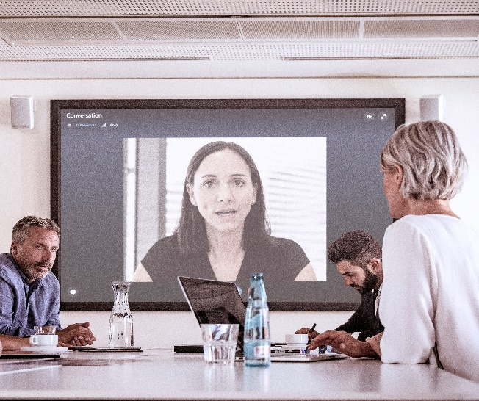 | Meets strict hygiene requirements: TeamConnect Ceiling 2 ensures a high level of speech intelligibility during video and audio conferences while still allowing social distancing rules to be observed

Ceiling microphone array with patented beamforming technology
The TeamConnect Ceiling 2 microphone array, which is specially designed for ceiling installation, can be elegantly integrated into every room environment and ensures that the participants’ contributions are transmitted with an outstanding level of detail regardless of their individual position in the room.

With its 28 condenser capsules that are intelligently linked via DSP matrixing, TeamConnect Ceiling 2 covers the entire room; the signal processing takes place within the microphone housing itself. Dependent on the signal level, the ceiling microphone recognises precisely where the speaker is located in the room and “focuses” on the corresponding area in the form of a beam. Other areas are attenuated accordingly.

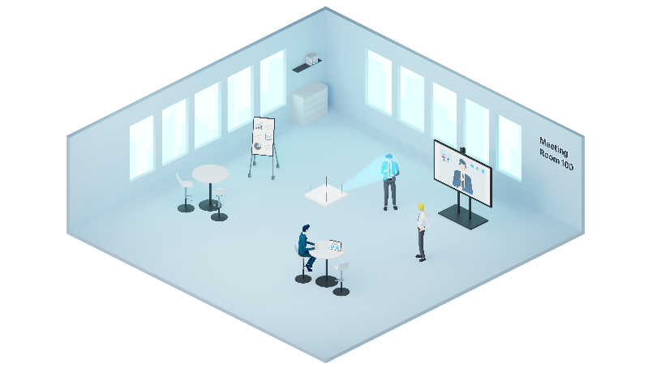 | TeamConnect Ceiling 2 focuses on the active speaker

Dynamic beamforming means that the ceiling microphone does not have to be adapted to different seating arrangements or changes in the number of people in the meeting. The system is therefore ideal for flexible collaboration scenarios or “ad hoc shared space” room utilisations, allowing participants to move around freely and speak anywhere in the space covered by TeamConnect Ceiling 2 without any need to reconfigure the settings.

Simple handling: the Sennheiser Control Cockpit software is available free of charge and makes it very easy to set up and operate TeamConnect Ceiling 2 | 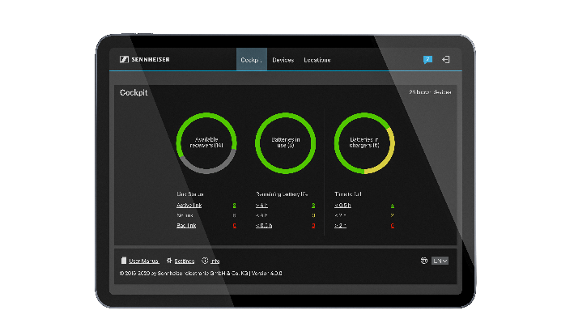

Audio output is through a three-pin Phoenix contact for analogue connection (external audio processor, video conference codec) and two Dante ports (primary/secondary, 2 x RJ45) for digital scenarios. Power is supplied by PoE (Power-over-Ethernet). Setting the system up and trouble-free AV workflows are best achieved by using the free Sennheiser Control Cockpit software 4.0.0, which also supports the evolution wireless G3 und G4 microphone series, as well as the SpeechLine Digital Wireless series and the ground-breaking Digital 6000 system. As an alternative, TeamConnect Ceiling 2 can also be operated with a media control system.

An extensive range of accessories makes it extremely easy to install the ceiling microphone, which measures 590 x 590 x 43 millimetres (L x W x H). Special paintwork in RAL colours is also available. Sennheiser TeamConnect Ceiling 2 is certified for use with Microsoft Teams Rooms together with a correspondingly certified DSP, and is compatible with Zoom.

Live webinar on touchless audio systems
If you would like to know more about touchless audio systems, why not join a live webinar with Sennheiser’s Andrew Kornstein? On June 17, 2020, he will be taking a look at the advances in microphone and assistive listening technology and will discuss TeamConnect Ceiling 2 and MobileConnect. Andrew will be happy to answer any questions you may have.

Andrew Kornstein will talk about advances in microphone technology and assistive listening systems

Touchless Audio Systems: Voice Lift and Assistive Listening
June 17, 2020, with two time options: 16:00 to 17:00 or 20:00 to 21:00 (CEST, Berlin time)
Please register at https://zoom.us/webinar/register/WN_dj7NDfPGTXOan3vb7oJQJg for the 16:00 to 17:00 session and at https://zoom.us/webinar/register/WN_8U_KewAaTECpHnNdjrXwmA for the 20:00 to 21:00 session.

The images accompanying this press release can be downloaded at https://sennheiser-brandzone.com/c/181/5yCrzGJc.

About Sennheiser
Founded in 1945, Sennheiser is celebrating its 75th anniversary this year. Shaping the future of audio and creating unique sound experiences for customers – this aim unites Sennheiser employees and partners worldwide. The independent family company, which is managed in the third generation by Dr. Andreas Sennheiser and Daniel Sennheiser, is today one of the world’s leading manufacturers of headphones, loudspeakers, microphones and wireless transmission systems. In 2018, the Sennheiser Group generated turnover totaling €710.7 million. www.sennheiser.com

Global Press Contact

Stephanie Schmidt
Stephanie.schmidt@sennheiser.com
+49 (5130) 600 – 1275

Local Press Contacts

Sarah James Maik Robbe
sarahj@gasolinemedia.com maik.robbe@sennheiser.com
+44 (0) 1483 223333 +44 (0) 7393 462484

